بسمه تعالی
فرم چکیده سخنرانی ژورنال کلاب دانشجویان دکترا ورودی
دانشکده بهداشت – گروه مهندسی بهداشت محیط

نام و نام خانوادگی دانشجو : مهسا علی کرد
شماره دانشجویی: 9711305002

استاد راهنمای آموزشی: دکتر نبی شریعتی فر عکس دانشجو:

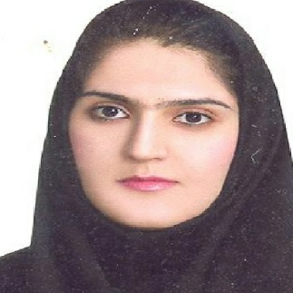

تاریخ : 2 خرداد 1400 ساعت:
عنوان مقاله :
- Occurrence and Exposure Assessment of Aflatoxins and Deoxynivalenol in Cereal-Based Baby Foods for Infants

چکیده :
Aflatoxins are carcinogenic to humans and deoxynivalenol causes digestive disorders, and both mycotoxins occur frequently in cereal-based foods. The purpose of this study was to investigate the occurrence and levels of aflatoxins (B1, B2, G1 and G2) and deoxynivalenol (DON) in cerealbased baby foods as well as to calculate the estimated daily intakes (EDI) in different stages of infancy. Sixty samples of infant cereals (wheat-, corn-, rice-, oat-, and mixed grain-based) were collected during a 2-year period and analyzed by validated methods. Aflatoxins were detected in 12 samples (20%), six of which exceeded the EU maximum level for aflatoxin B1 set at 0.10 _g/kg. Deoxynivalenol appeared in 20% of baby food samples, with one sample exceeding the EU maximum level established at 200 _g/kg. There were no significant differences between glutenfree products for babies aged 4–6 months and multi-cereal products for infants aged 7–12 months, nor between whole-grain-based and refined ingredients. However, baby food products of organic origin showed significantly higher levels of deoxynivalenol than conventional ones (p < 0.05). It is proposed for the health protection of infants and young children, a vulnerable group, to establish the lowest maximum level for the sum of aflatoxins (B1, B2, G1 and G2) in baby food.

